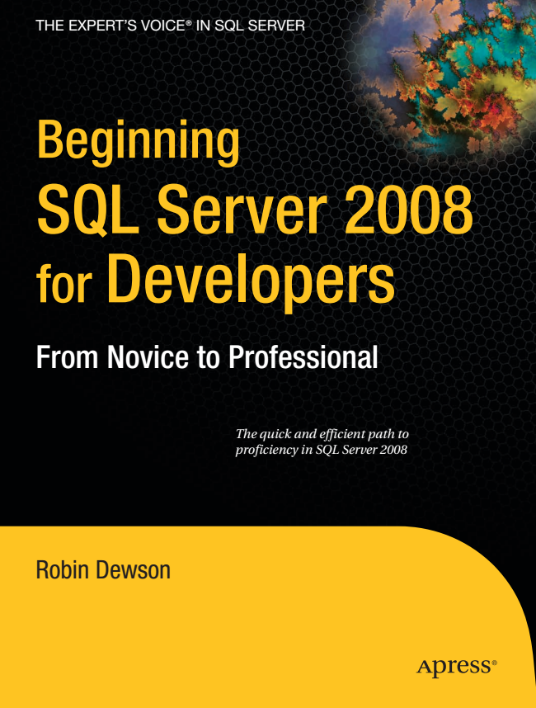

**mpanion k Available**

Beginning

*The quick and efficient path to proficiency in SQL Server 2008*

Dewson

THE EXPERTLS VOICE® IN SQL SERVER

Beginning SQL Server 2008 for

Developers

From Novice to Professional

Robin Dewson



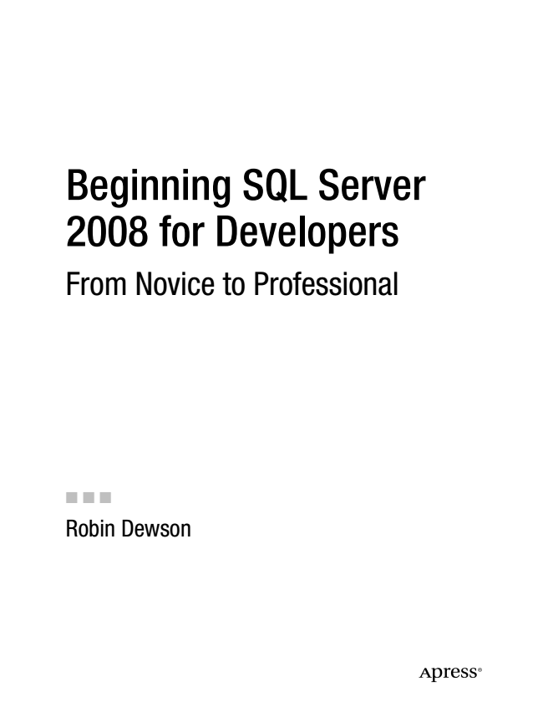

Dewson_958-7FRONT.fm Page i Thursday, July 3, 2008 3:20 PM

Beginning SQL Server 2008 for Developers From Novice to Professional

■■■ Robin Dewson



Dewson_958-7FRONT.fm Page ii Thursday, July 3, 2008 3:20 PM

**Beginning SQL Server 2008 for Developers: From Novice to Professional**

**Copyright © 2008 by Robin Dewson**

All rights reserved. No part of this work may be reproduced or transmitted in any form or by any means, electronic or mechanical, including photocopying, recording, or by any information storage or retrieval system, without the prior written permission of the copyright owner and the publisher.

ISBN-13 (pbk): 978-1-59059-958-7

ISBN-10 (pbk): 1-59059-958-6

ISBN-13 (electronic): 978-1-4302-0584-5

ISBN-10 (electronic): 1-4302-0584-9

Printed and bound in the United States of America 9 8 7 6 5 4 3 2 1

Trademarked names may appear in this book. Rather than use a trademark symbol with every occurrence of a trademarked name, we use the names only in an editorial fashion and to the benefit of the trademark owner, with no intention of infringement of the trademark.

Lead Editor: Jonathan Gennick Technical Reviewer: Jasper Smith Editorial Board: Clay Andres, Steve Anglin, Ewan Buckingham, Tony Campbell, Gary Cornell,

Jonathan Gennick, Matthew Moodie, Joseph Ottinger, Jeffrey Pepper, Frank Pohlmann, Ben Renow-Clarke, Dominic Shakeshaft, Matt Wade, Tom Welsh Project Manager: Kylie Johnston Copy Editor: Nicole Abramowitz Associate Production Director: Kari Brooks-Copony Production Editor: Ellie Fountain Compositor: Susan Glinert Proofreader: Nancy Sixsmith, ConText Editorial Services, Inc. Indexer: Broccoli Information Management Artist: Kinetic Publishing Services, LLC Cover Designer: Kurt Krames Manufacturing Director: Tom Debolski

Distributed to the book trade worldwide by Springer-Verlag New York, Inc., 233 Spring Street, 6th Floor, New York, NY 10013. Phone 1-800-SPRINGER, fax 201-348-4505, e-mail orders-ny@springer-sbm.com, or visit http://www.springeronline.com.

For information on translations, please contact Apress directly at 2855 Telegraph Avenue, Suite 600, Berkeley, CA 94705. Phone 510-549-5930, fax 510-549-5939, e-mail info@apress.com, or visit http:// www.apress.com.

Apress and friends of ED books may be purchased in bulk for academic, corporate, or promotional use. eBook versions and licenses are also available for most titles. For more information, reference our Special Bulk Sales–eBook Licensing web page at http://www.apress.com/info/bulksales.

The information in this book is distributed on an “as is” basis, without warranty. Although every precaution has been taken in the preparation of this work, neither the author(s) nor Apress shall have any liability to any person or entity with respect to any loss or damage caused or alleged to be caused directly or indirectly by the information contained in this work.

The source code for this book is available to readers at http://www.apress.com.



Dewson_958-7FRONT.fm Page iii Thursday, July 3, 2008 3:20 PM

*This book, as many of my books are, is dedicated to my family. First, to my mum and dad whom I love very much and who made me what I am today. Without their help, under- standing, and patience when it came to my use of the television for the Sinclair ZX80 and the Sinclair ZX81, and without helping me find and organize my further education, I probably would have wasted a great opportunity. To my three kids—Ellen, Cameron, and Scott—who have been brilliant and wonderful and whom I am very, very proud of in many ways. And they are such great kids because they have who can only be termed the best mother kids can have, right there helping, loving, and, yes, screaming at them when needed. Julie, I love you more than I love my Irn-Bru, rugby, and lemon meringue pie . . . and you know how much those mean to me!*

**

Dewson_958-7FRONT.fm Page iv Thursday, July 3, 2008 3:20 PM

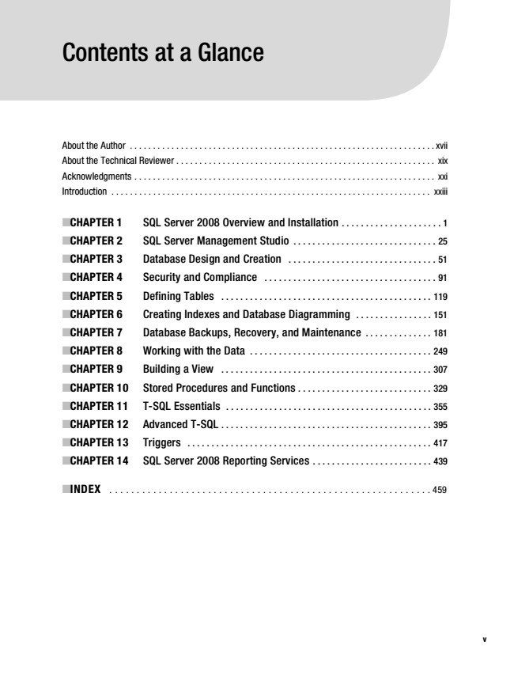

Dewson_958-7FRONT.fm Page v Thursday, July 3, 2008 3:20 PM

Contents at a Glance

About the Author . . . . . . . . . . . . . . . . . . . . . . . . . . . . . . . . . . . . . . . . . . . . . . . . . . . . . . . . . . . . . . . . . . xvii About the Technical Reviewer . . . . . . . . . . . . . . . . . . . . . . . . . . . . . . . . . . . . . . . . . . . . . . . . . . . . . . . . xix Acknowledgments . . . . . . . . . . . . . . . . . . . . . . . . . . . . . . . . . . . . . . . . . . . . . . . . . . . . . . . . . . . . . . . . . xxi Introduction . . . . . . . . . . . . . . . . . . . . . . . . . . . . . . . . . . . . . . . . . . . . . . . . . . . . . . . . . . . . . . . . . . . . . xxiii

■CHAPTER 1 SQL Server 2008 Overview and Installation . . . . . . . . . . . . . . . . . . . . . 1

■CHAPTER 2 SQL Server Management Studio . . . . . . . . . . . . . . . . . . . . . . . . . . . . . . 25

■CHAPTER 3 Database Design and Creation . . . . . . . . . . . . . . . . . . . . . . . . . . . . . . . 51

■CHAPTER 4 Security and Compliance . . . . . . . . . . . . . . . . . . . . . . . . . . . . . . . . . . . . 91

■CHAPTER 5 Defining Tables . . . . . . . . . . . . . . . . . . . . . . . . . . . . . . . . . . . . . . . . . . . . 119

■CHAPTER 6 Creating Indexes and Database Diagramming . . . . . . . . . . . . . . . . 151

■CHAPTER 7 Database Backups, Recovery, and Maintenance . . . . . . . . . . . . . . 181

■CHAPTER 8 Working with the Data . . . . . . . . . . . . . . . . . . . . . . . . . . . . . . . . . . . . . . 249

■CHAPTER 9 Building a View . . . . . . . . . . . . . . . . . . . . . . . . . . . . . . . . . . . . . . . . . . . . 307

■CHAPTER 10 Stored Procedures and Functions . . . . . . . . . . . . . . . . . . . . . . . . . . . . 329

■CHAPTER 11 T-SQL Essentials . . . . . . . . . . . . . . . . . . . . . . . . . . . . . . . . . . . . . . . . . . . 355

■CHAPTER 12 Advanced T-SQL . . . . . . . . . . . . . . . . . . . . . . . . . . . . . . . . . . . . . . . . . . . . 395

■CHAPTER 13 Triggers . . . . . . . . . . . . . . . . . . . . . . . . . . . . . . . . . . . . . . . . . . . . . . . . . . . 417

■CHAPTER 14 SQL Server 2008 Reporting Services . . . . . . . . . . . . . . . . . . . . . . . . . 439

■INDEX . . . . . . . . . . . . . . . . . . . . . . . . . . . . . . . . . . . . . . . . . . . . . . . . . . . . . . . . . . . 459

**v**



Dewson_958-7FRONT.fm Page vi Thursday, July 3, 2008 3:20 PM

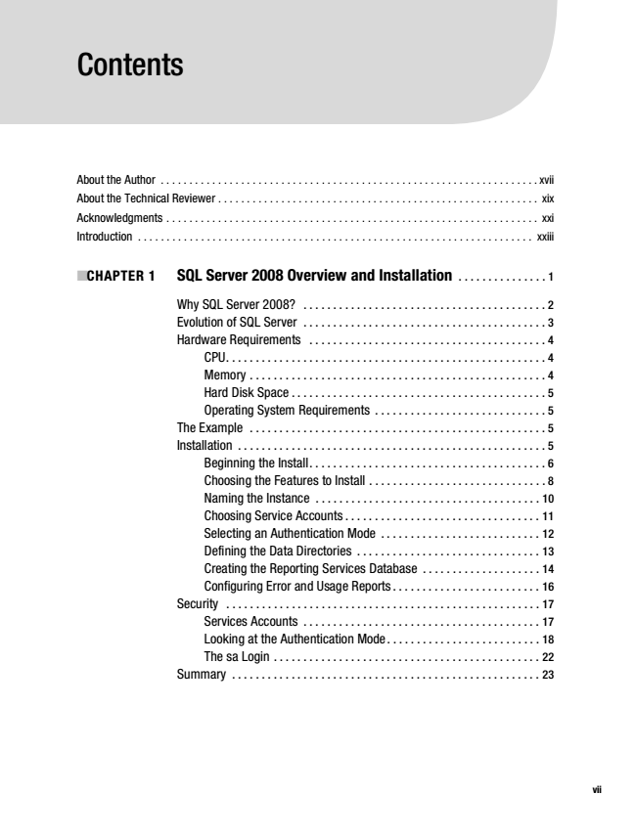

Dewson_958-7FRONT.fm Page vii Thursday, July 3, 2008 3:20 PM

Contents

About the Author . . . . . . . . . . . . . . . . . . . . . . . . . . . . . . . . . . . . . . . . . . . . . . . . . . . . . . . . . . . . . . . . . . xvii About the Technical Reviewer . . . . . . . . . . . . . . . . . . . . . . . . . . . . . . . . . . . . . . . . . . . . . . . . . . . . . . . . xix Acknowledgments . . . . . . . . . . . . . . . . . . . . . . . . . . . . . . . . . . . . . . . . . . . . . . . . . . . . . . . . . . . . . . . . . xxi Introduction . . . . . . . . . . . . . . . . . . . . . . . . . . . . . . . . . . . . . . . . . . . . . . . . . . . . . . . . . . . . . . . . . . . . . xxiii

**■CHAPTER 1 SQL Server 2008 Overview and Installation**

. . . . . . . . . . . . . . . 1

Why SQL Server 2008? . . . . . . . . . . . . . . . . . . . . . . . . . . . . . . . . . . . . . . . . . 2 Evolution of SQL Server . . . . . . . . . . . . . . . . . . . . . . . . . . . . . . . . . . . . . . . . . 3 Hardware Requirements . . . . . . . . . . . . . . . . . . . . . . . . . . . . . . . . . . . . . . . . 4 CPU. . . . . . . . . . . . . . . . . . . . . . . . . . . . . . . . . . . . . . . . . . . . . . . . . . . . . . 4 Memory . . . . . . . . . . . . . . . . . . . . . . . . . . . . . . . . . . . . . . . . . . . . . . . . . . 4 Hard Disk Space . . . . . . . . . . . . . . . . . . . . . . . . . . . . . . . . . . . . . . . . . . . 5 Operating System Requirements . . . . . . . . . . . . . . . . . . . . . . . . . . . . . 5 The Example . . . . . . . . . . . . . . . . . . . . . . . . . . . . . . . . . . . . . . . . . . . . . . . . . . 5 Installation . . . . . . . . . . . . . . . . . . . . . . . . . . . . . . . . . . . . . . . . . . . . . . . . . . . . 5 Beginning the Install. . . . . . . . . . . . . . . . . . . . . . . . . . . . . . . . . . . . . . . . 6 Choosing the Features to Install . . . . . . . . . . . . . . . . . . . . . . . . . . . . . . 8 Naming the Instance . . . . . . . . . . . . . . . . . . . . . . . . . . . . . . . . . . . . . . 10 Choosing Service Accounts . . . . . . . . . . . . . . . . . . . . . . . . . . . . . . . . . 11 Selecting an Authentication Mode . . . . . . . . . . . . . . . . . . . . . . . . . . . 12 Defining the Data Directories . . . . . . . . . . . . . . . . . . . . . . . . . . . . . . . 13 Creating the Reporting Services Database . . . . . . . . . . . . . . . . . . . . 14 Configuring Error and Usage Reports . . . . . . . . . . . . . . . . . . . . . . . . . 16 Security . . . . . . . . . . . . . . . . . . . . . . . . . . . . . . . . . . . . . . . . . . . . . . . . . . . . . 17 Services Accounts . . . . . . . . . . . . . . . . . . . . . . . . . . . . . . . . . . . . . . . . 17 Looking at the Authentication Mode. . . . . . . . . . . . . . . . . . . . . . . . . . 18 The sa Login . . . . . . . . . . . . . . . . . . . . . . . . . . . . . . . . . . . . . . . . . . . . . 22 Summary . . . . . . . . . . . . . . . . . . . . . . . . . . . . . . . . . . . . . . . . . . . . . . . . . . . . 23

**vii**

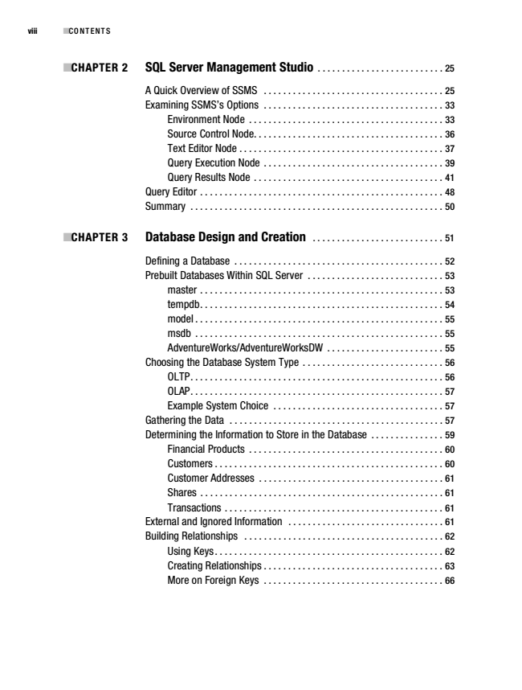

Dewson_958-7FRONT.fm Page viii Thursday, July 3, 2008 3:20 PM

viii ■CONTENTS

**■CHAPTER 2 SQL Server Management Studio**

. . . . . . . . . . . . . . . . . . . . . . . . . . 25

A Quick Overview of SSMS . . . . . . . . . . . . . . . . . . . . . . . . . . . . . . . . . . . . . 25 Examining SSMS’s Options . . . . . . . . . . . . . . . . . . . . . . . . . . . . . . . . . . . . . 33 Environment Node . . . . . . . . . . . . . . . . . . . . . . . . . . . . . . . . . . . . . . . . 33 Source Control Node. . . . . . . . . . . . . . . . . . . . . . . . . . . . . . . . . . . . . . . 36 Text Editor Node . . . . . . . . . . . . . . . . . . . . . . . . . . . . . . . . . . . . . . . . . . 37 Query Execution Node . . . . . . . . . . . . . . . . . . . . . . . . . . . . . . . . . . . . . 39 Query Results Node . . . . . . . . . . . . . . . . . . . . . . . . . . . . . . . . . . . . . . . 41 Query Editor . . . . . . . . . . . . . . . . . . . . . . . . . . . . . . . . . . . . . . . . . . . . . . . . . . 48 Summary . . . . . . . . . . . . . . . . . . . . . . . . . . . . . . . . . . . . . . . . . . . . . . . . . . . . 50

**■CHAPTER 3 Database Design and Creation**

. . . . . . . . . . . . . . . . . . . . . . . . . . . 51

Defining a Database . . . . . . . . . . . . . . . . . . . . . . . . . . . . . . . . . . . . . . . . . . . 52 Prebuilt Databases Within SQL Server . . . . . . . . . . . . . . . . . . . . . . . . . . . . 53 master . . . . . . . . . . . . . . . . . . . . . . . . . . . . . . . . . . . . . . . . . . . . . . . . . . 53 tempdb. . . . . . . . . . . . . . . . . . . . . . . . . . . . . . . . . . . . . . . . . . . . . . . . . . 54 model . . . . . . . . . . . . . . . . . . . . . . . . . . . . . . . . . . . . . . . . . . . . . . . . . . . 55 msdb . . . . . . . . . . . . . . . . . . . . . . . . . . . . . . . . . . . . . . . . . . . . . . . . . . . 55 AdventureWorks/AdventureWorksDW . . . . . . . . . . . . . . . . . . . . . . . . 55 Choosing the Database System Type . . . . . . . . . . . . . . . . . . . . . . . . . . . . . 56 OLTP. . . . . . . . . . . . . . . . . . . . . . . . . . . . . . . . . . . . . . . . . . . . . . . . . . . . 56 OLAP. . . . . . . . . . . . . . . . . . . . . . . . . . . . . . . . . . . . . . . . . . . . . . . . . . . . 57 Example System Choice . . . . . . . . . . . . . . . . . . . . . . . . . . . . . . . . . . . 57 Gathering the Data . . . . . . . . . . . . . . . . . . . . . . . . . . . . . . . . . . . . . . . . . . . . 57 Determining the Information to Store in the Database . . . . . . . . . . . . . . . 59 Financial Products . . . . . . . . . . . . . . . . . . . . . . . . . . . . . . . . . . . . . . . . 60 Customers . . . . . . . . . . . . . . . . . . . . . . . . . . . . . . . . . . . . . . . . . . . . . . . 60 Customer Addresses . . . . . . . . . . . . . . . . . . . . . . . . . . . . . . . . . . . . . . 61 Shares . . . . . . . . . . . . . . . . . . . . . . . . . . . . . . . . . . . . . . . . . . . . . . . . . . 61 Transactions . . . . . . . . . . . . . . . . . . . . . . . . . . . . . . . . . . . . . . . . . . . . . 61 External and Ignored Information . . . . . . . . . . . . . . . . . . . . . . . . . . . . . . . . 61 Building Relationships . . . . . . . . . . . . . . . . . . . . . . . . . . . . . . . . . . . . . . . . . 62 Using Keys. . . . . . . . . . . . . . . . . . . . . . . . . . . . . . . . . . . . . . . . . . . . . . . 62 Creating Relationships . . . . . . . . . . . . . . . . . . . . . . . . . . . . . . . . . . . . . 63 More on Foreign Keys . . . . . . . . . . . . . . . . . . . . . . . . . . . . . . . . . . . . . 66